



NOVEMBER 2025 – JULY 2026
2025 - 2026
CALENDAR


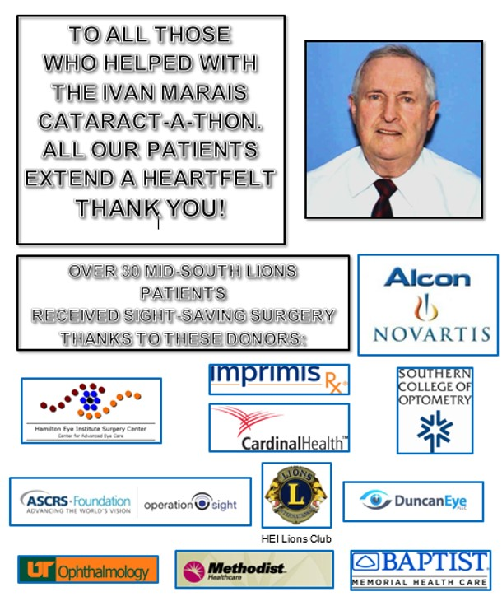

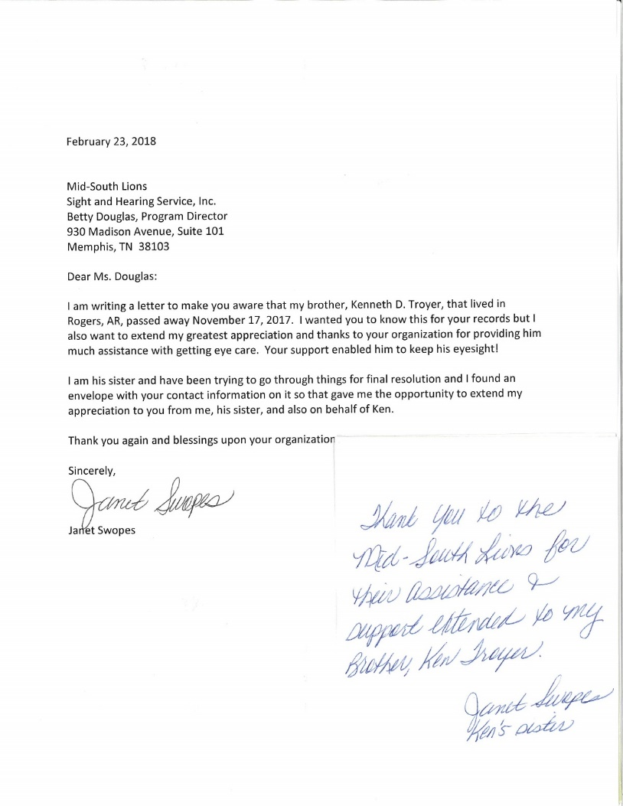
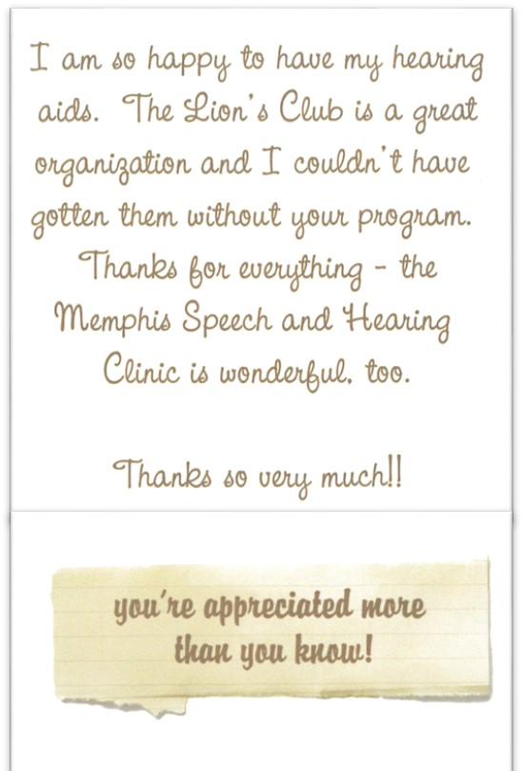
GIVE
THANKS
November 2025
Sunday | Monday | Tuesday | Wednesday | Thursday | Friday | Saturday
 |  |  |  |  |  | 1
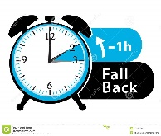  2 | 3 |   4 | 5 |   6 | 7  DISTRICT MEETING  7 - I | 8
9 | 10 |   11 | 12 | 13 | 14  QUARTERLY MEETING OVERLAND, MO | 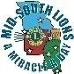  15
16 | 17 | 18 | 19 | 20 | 21 | 22
23 | 24 | 25 | 26 | 27 | 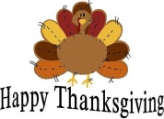  28  OFFICE CLOSED | 29
30


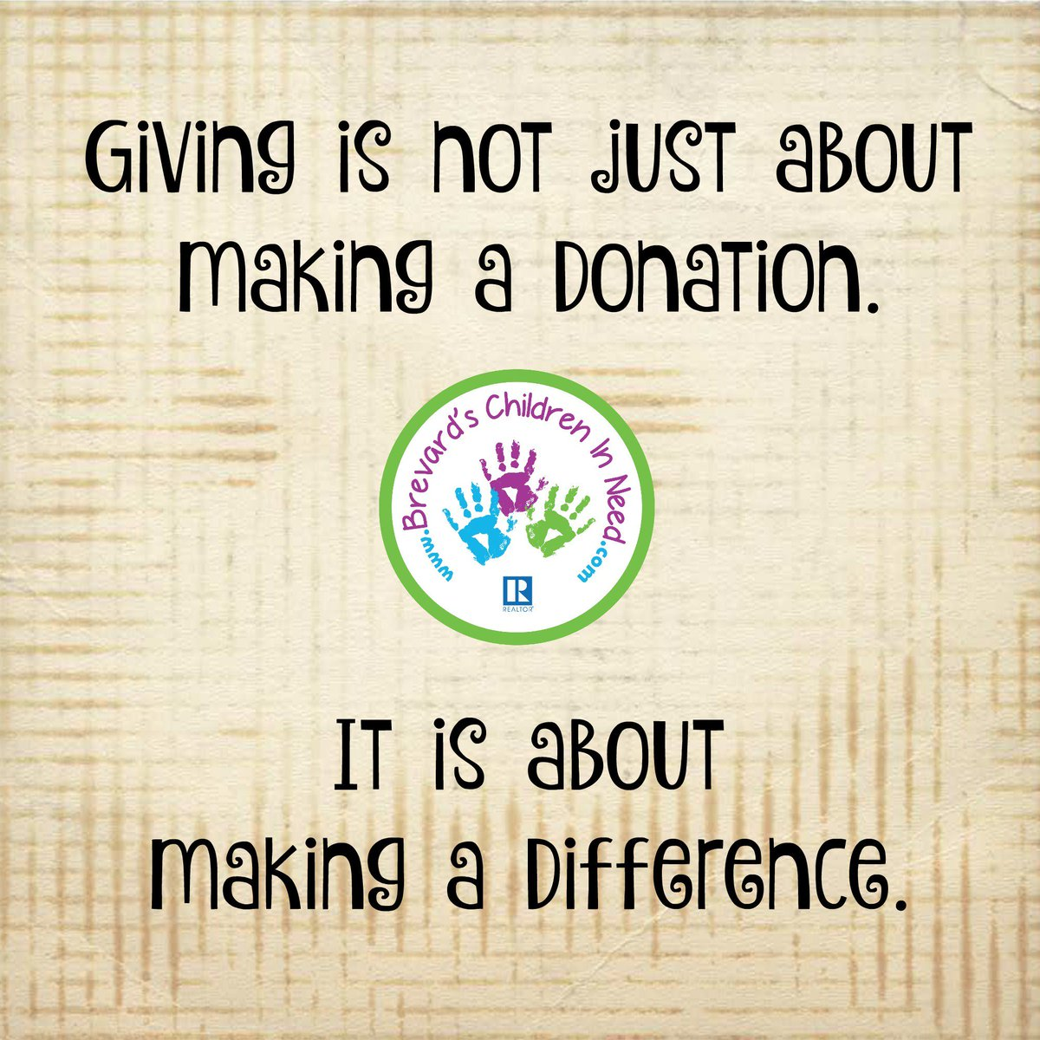
You can help Mid-South give someone the gift
Of sight or hearing TODAY!
Become a CHAMPION at www.midsouthlions.org
December 2025
Sunday |   Monday | Tuesday | Wednesday | Thursday | Friday | Saturday
 | 1 | 2 | 3 | 4 | 5 | 6
7 | 8 | 9 | 10 | 11 | 12 | 13
14 |   15  HANUKKAH IS DECEMBER 14 – 22 | 16 | 17 | 18 | 19 | 20
21  OFFICE CLOSED | 22  OFFICE CLOSED | 23 | 24 |   25 | 26 | 27
28  OFFICE CLOSED | 29 | 30 | 31


Resolve to become a CHAMPION at www.midsouthlions.org
It’s a resolution that brings the gift of sight!
Sunday | Monday | Tuesday | Wednesday | Thursday | Friday | Saturday
 |  |  |  |   1 | 2 | 3
4 | 5 | 6 | 7 | 8 | 9  DISTRICT MEETING  30 - S | 10
11 |   12 | 13 | 14 | 15 | 16 | 17  UMKC  C – A - T  TENNESSEE LLR
18 | 19 | 20 | 21 | 22 | 23 | 24  MECA  CATARACT-A-THON
25 | 26 | 27 | 28 | 29 | 30 | 31
January 2026



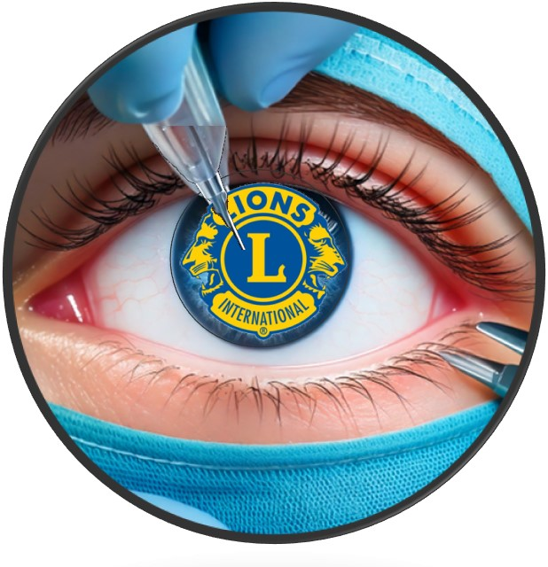
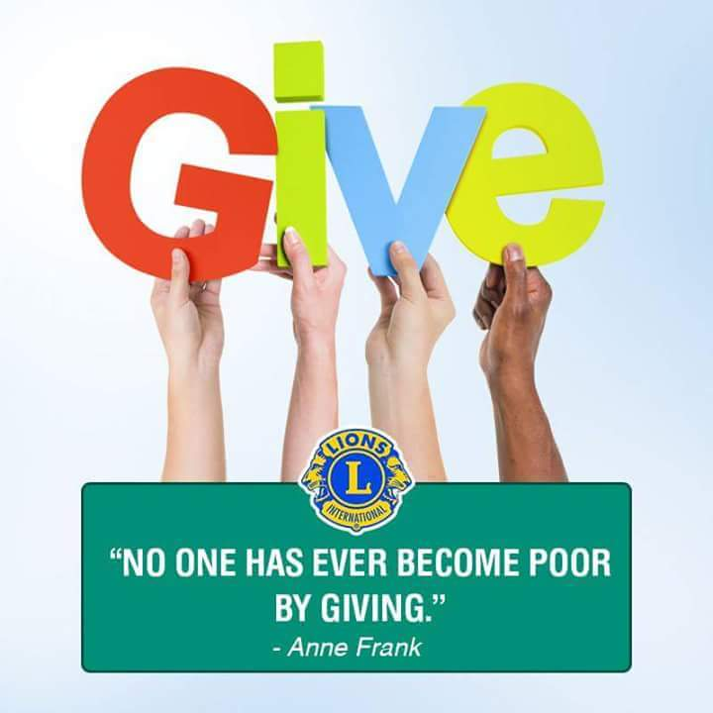

February 2026
Sunday | Monday | Tuesday | Wednesday | Thursday | Friday | Saturday
 |  |  |  |  |  | 1
2 | 3 | 4 | 5 | 6 | 7 | 8
9 | 10 | 11 | 12 | 13 |   14  DISTRICT MEETING  MD-7I | 15
16 |   17 | 18 | 19 | 20 | 21 | 22  DISTRICT MEETING  M - 1
23 | 24 | 25 | 26 | 27 | 28  DISTRICT MEETING  M - 6
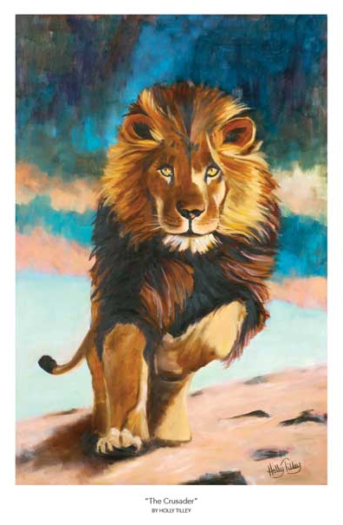
“The Crusader” By Holly Tilley
“The Monarch”
By Phillip Crowe
AND “Fab Lion”
By Dr. Fab Anbar
Make great gifts, fit every décor
And help Mid-South
Make MIRACLES!
You can also get personalized cards with this artwork
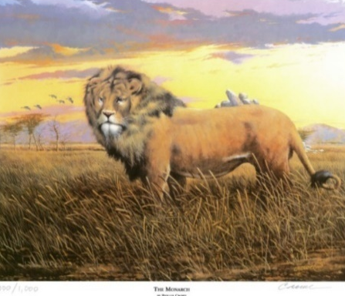
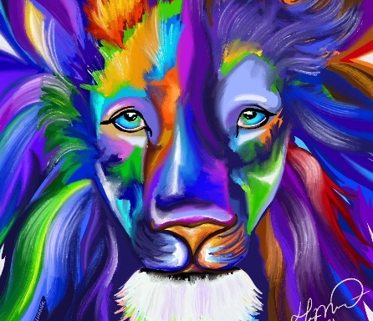
March 2026
Sunday | Monday | Tuesday | Wednesday | Thursday | Friday | Saturday
 |  |  |  |  |  | 1
2 | 3 | 4 | 5 | 6 | 7 | 8  THIRD QUARTERLY MEETING  DISTRICT MEETING M-7
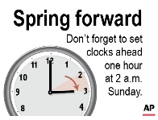  9 | 10 | 11 | 12 | 13 | 14  DISTRICT MEETING  M - 4 | 15
16 |   17 | 18 | 19 | 20 | 21  DISTRICT MEETING  M-2 & M-3 | 22
23 | 24 | 25 | 26 | 27 | 28 | 29
30 | 31
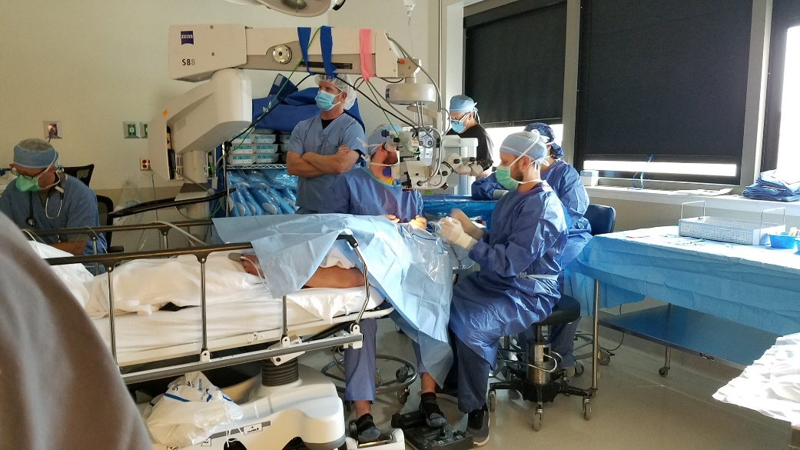
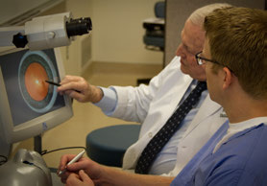
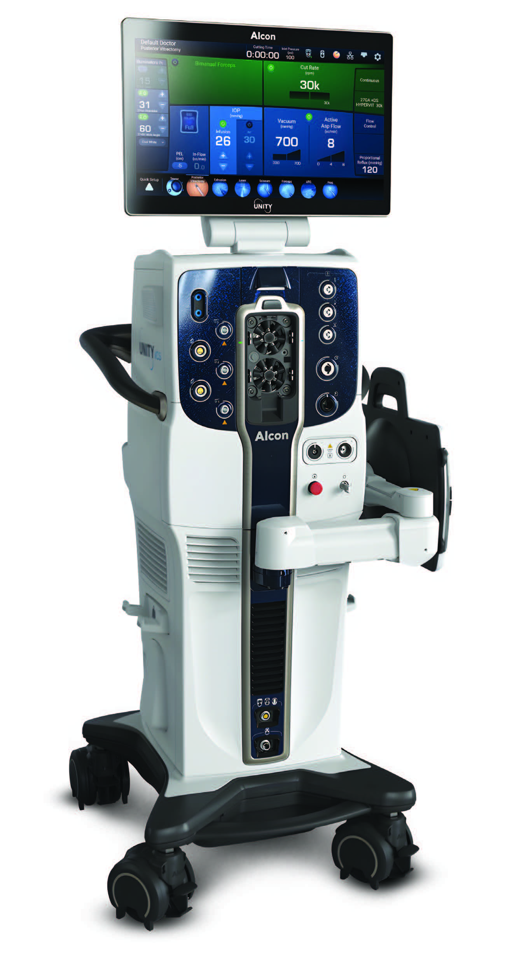

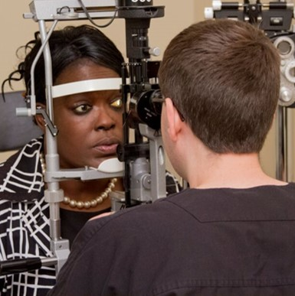
SHOWERS OF SERVICE
TO THOSE IN NEED

April 2026
Sunday | Monday | Tuesday | Wednesday | Thursday | Friday | Saturday
 |  |  | 1 | 2 |   3 | 4
  5 | 6 | 7 | 8 | 9 |   10  VISTING LIONS WEEKEND | 11
12 | 13 | 14 | 15 | 16 | 17 | 18
19 | 20 | 21 | 22 | 23 | 24  MD-26 STATE CONVENTION  ST. JOSEPH | 25  MD-7 STATE CONVENTION  LITTLE ROCK
26 | 27 | 28 | 29 | 30 | MD-12 STATE CONVENTION  CLARKSVILLE


Thanks to some of our most generous donors:
LCIF * Lakeland, TN Lions * Missouri District 26M2 Eye Foundation
West Tennessee Lions Foundation * Dr. Emily Graves
Arkansas Lions Eye Bank Foundation * PDG Bill Freeman
Hamilton Eye Institute Surgery Center * MECA
Methodist University Hospital * Methodist Le Bonheur Healthcare
Hot Springs Village Evening Lions * Rolla, MO Lions
Jonesboro University Heights, AR Lions * Bartlett, TN Lions
Germantown, TN Lions * Batesville, MS Lions * Hope, AR Lions
Jackson, TN Old Hickory Lions * Fayetteville, AR Lions
All our CHAMPION Lions
And all Lions and Lions Clubs in the four-state area
May 2026
Sunday | Monday | Tuesday | Wednesday | Thursday | Friday | Saturday
 |  |  |  |  | 1  MD-30 STATE CONVENTION  VICKSBURG (TENTATIVE) | 2  MD-12 STATE CONVENTION  CLARKSVILLE
3  MD-12  ST CONV | 4 | 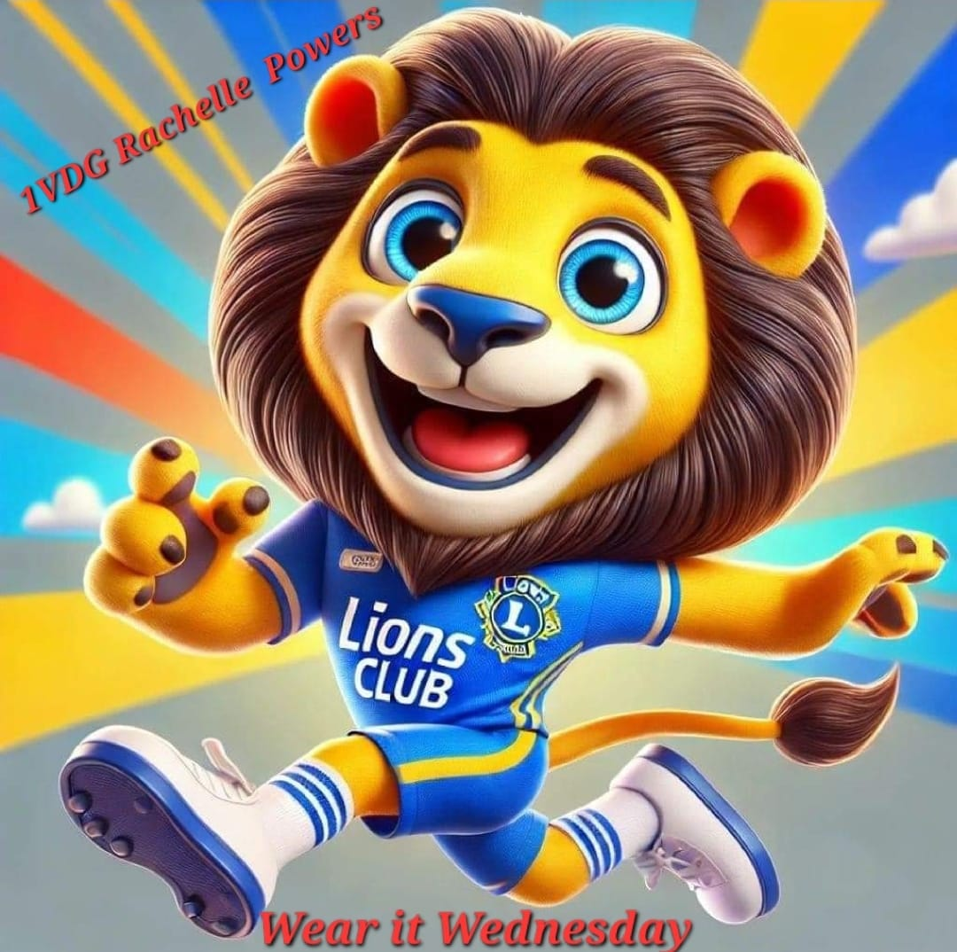  5 | 6 | 7 | 8 | 9
  10 | 11 | 12 | 13 | 14 | 15 | 16
17 | 18 | 19 | 20 | 21 | 22 | 23
24 |   25 | 26 | 27 | 28 | 29 | 30
31

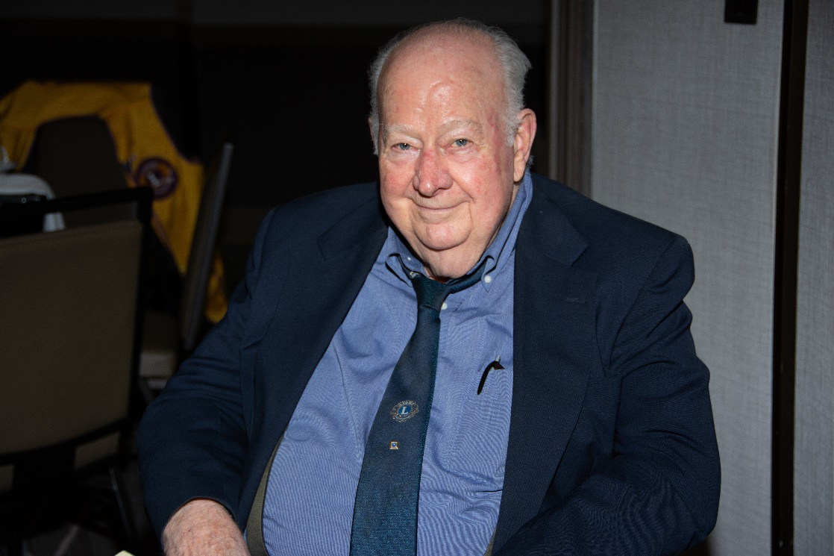
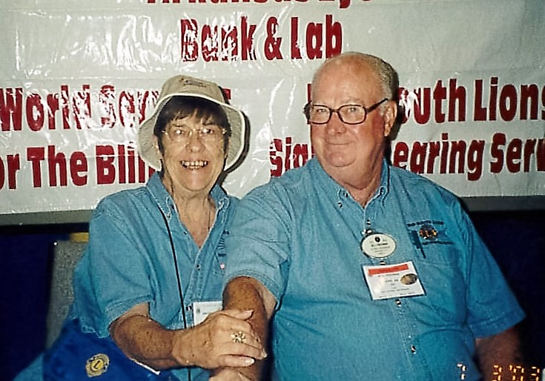
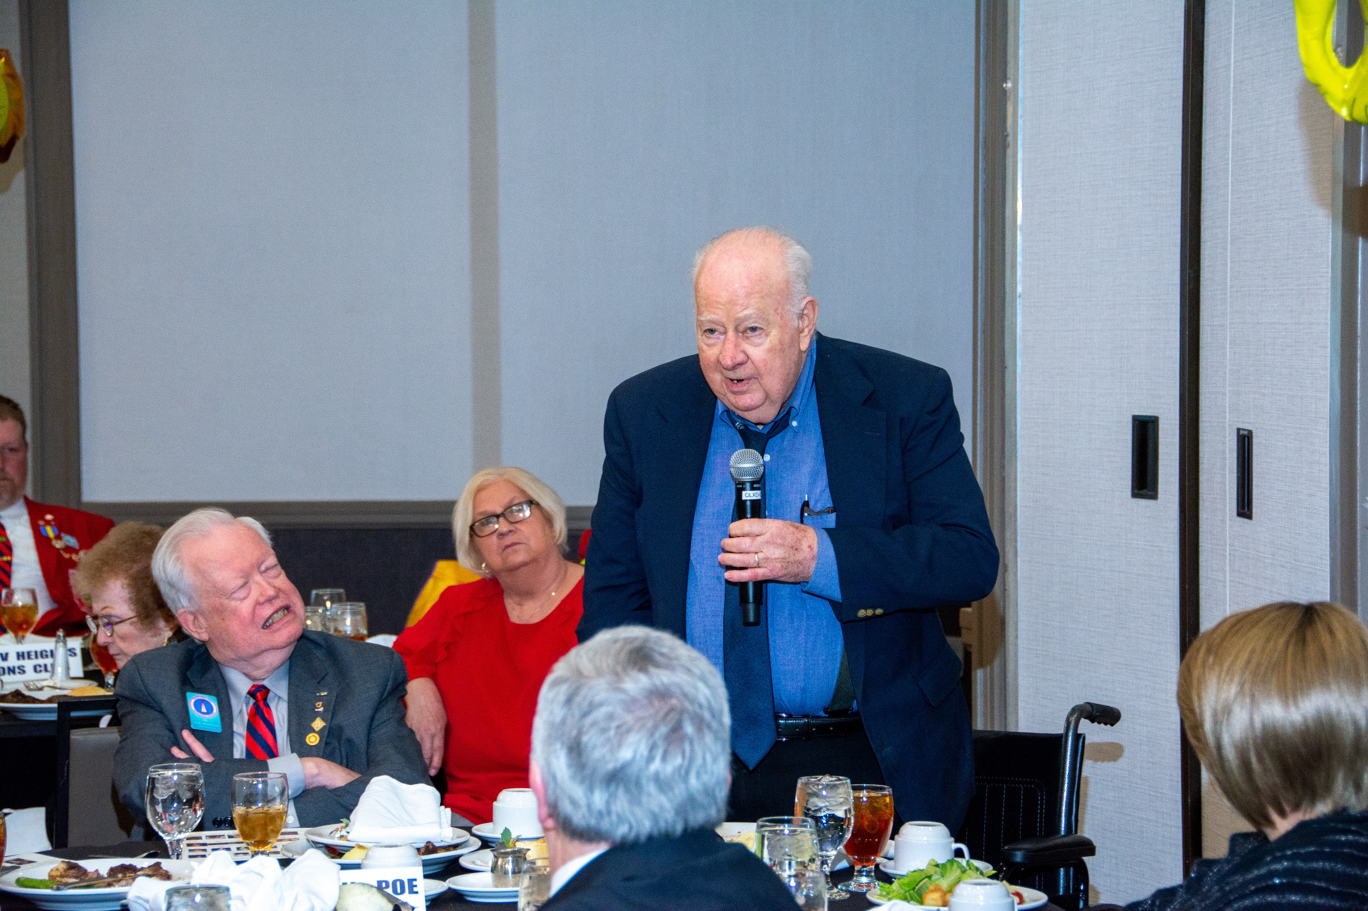
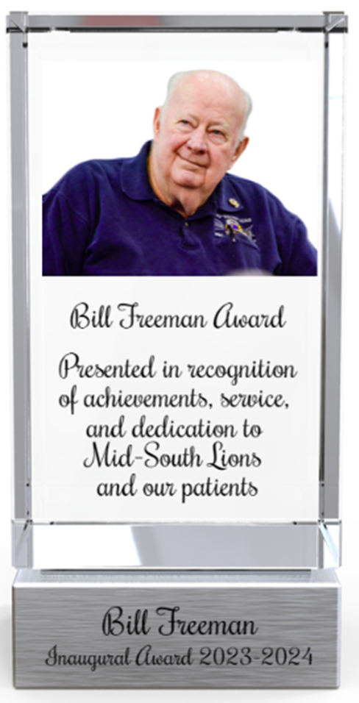
PDG Bill Freeman is the ultimate Lions example of a servant leader. For his outstanding work over several decades, the organization has honored him through the naming of this award. The Executive Committee recommends potential recipients to the President who makes the selection for presentation at the annual meeting.
The Bill Freeman Award
is presented annually
*
June 2026
Sunday | Monday | Tuesday | Wednesday | Thursday |   Friday | Saturday
 | 1 |   2 | 3 | 4 | 5 |   6
7 | 8 | 9 | 10 | 11 | 12 | 13
  14 | 15 | 16 | 17 | 18 | 19 | 20
21 | 22 | 23 | 24 | 25 | 26 | 27
28 | 29 | 30
LIONS CLUBS INTERNATIONAL CONVENTION
JULY 3 – 6, 2026, HONG KONG, CHINA

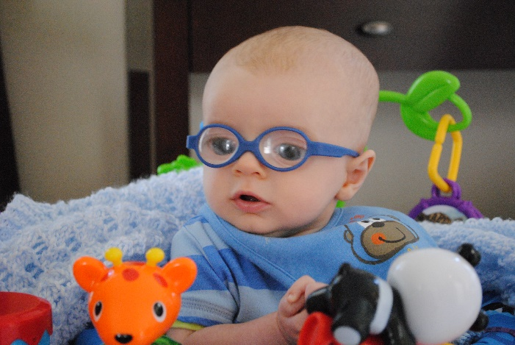

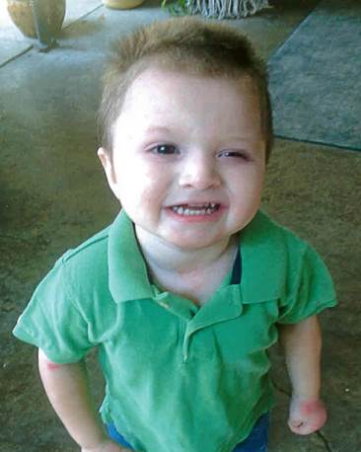
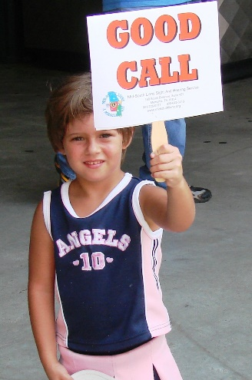
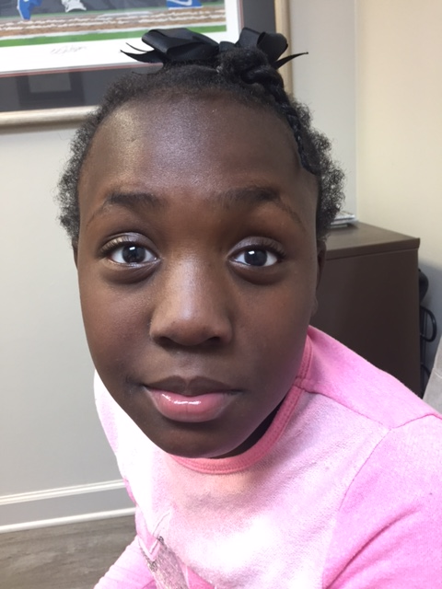
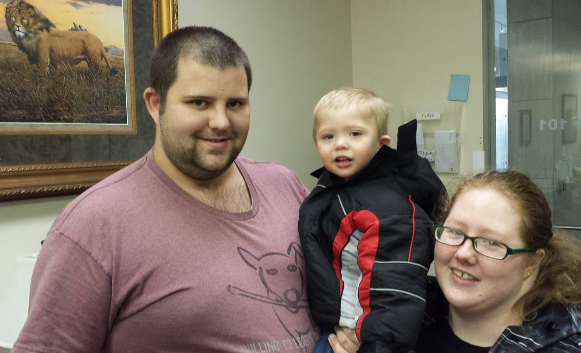
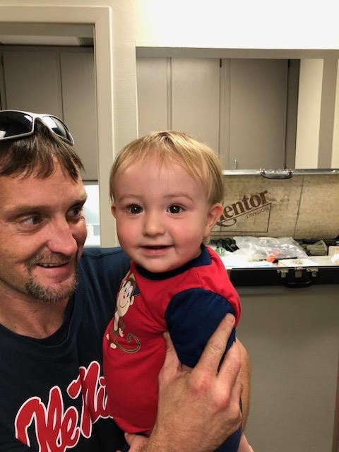
HELPING YOUNG PEOPLE IN YOUR SERVICE AREA
IS ALWAYS A GOOD CALL!
Sunday | Monday | Tuesday | Wednesday | Thursday | Friday | Saturday
 |  |  | 1 | 2 | 3 |   4
5 |   6 | 7 | 8 | 9 | 10 | 11
12 | 13 | 14 | 15 | 16 | 17 | 18
19 | 20 | 21 | 22 | 23 | 24 | 25
26 | 27 | 28 | 29 | 30 | 31
July 2026


